Lab Assignment 01

Introduction to Flowcharts

and Java Programming



CSE110: Programming Language I

| **No of Tasks** | **Points to Score** |
| --- | --- |
| **20** | ***200*** |

[Submit all the Flowchart Tasks (Task 1 to 9) handwritten to your Lab Instructors before the next lab. Submit all the Coding Tasks (Task 10 to 20) in the Google Form shared on buX.]

Lab Policy: [Lab-Policy-Student-Version-Fall-2024-Onward.pdf](https://drive.google.com/file/d/1XGZeQRfOlzI2G6oNH0zLzz2J2TvQACMI/view?usp=sharing)  
[Must Read Before Starting Lab of CSE110. Also, Submit a Signed Copy to the Lab Faculties.]

# 5

# **FLOWCHART TASKS**

1. Design a flowchart to take a number as input, store it in a variable, and print its cube.
2. Create a flowchart to convert a temperature in Fahrenheit to Celsius. The user should input the temperature in Fahrenheit, and the flowchart should display the corresponding temperature in Celsius. The formula to convert Celsius to Fahrenheit is:

C = (F - 32) × 5/9

1. Design a flowchart to take three integers a, b and h as input, where a and b are the length of the parallel sides of a trapezium, h is the distance between the parallel sides, and print the area of the trapezium.
2. Create a flowchart to find the average of three numbers. The flowchart should take three inputs from the user and display their average.
3. Design a flowchart to take an integer consisting of 4 digits as input and print the last 2 digits of that number.
4. Design a flowchart to take an integer consisting of 4 digits as input and print the first 2 digits of that number.
5. Design a flowchart to take three integers a, n, d as input where a is the first term of an arithmetic sequence, n is the number of terms and d is the common difference between the terms in the sequence, and print the n-th term of the arithmetic sequence.
6. Design a flowchart to take two numbers a and c as input (look at the image below), and print the area of the portion colored in green. In the following image, a is the radius of the circle, and c is the length of the sides of the square.

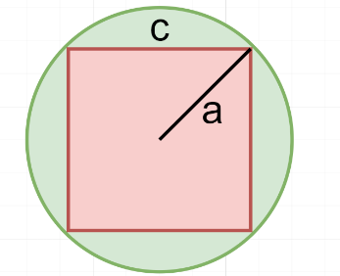

1. Design a flowchart to take a number a as input (look at the image below), and print the area of the portion colored in red. In the following image, a is the diameter of the circle.

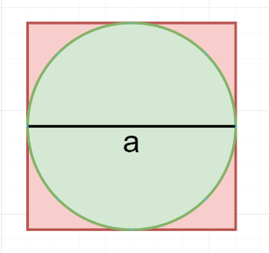

For this course, we’ll be using **DrJava** as IDE for Java Coding:

[**Link to JDK and DrJava**](https://drive.google.com/drive/folders/1pzTIouwS9-tHVEb9HdBnp1WL7NDrK_BI)

**DrJava Installation Guide:**

[**https://www.youtube.com/watch?v=Gss9sL3Q-8s**](https://www.youtube.com/watch?v=Gss9sL3Q-8s)

# **CODING TASKS**

1. Find out which of the following are legal identifiers in Java, and which are not.

Also, explain why the invalid ones are invalid. You can try to define each of these (items a to k below) as a variable in the Dr java interaction pane and find out.

The first one is done for you as an Example. If you want to define hungry, you have to try

**int hungry;**

a) hungry b) 2AB c) 312.2 d) MOBILE e) “Ans” f) $30

g) Yes/No h) student-id i) A+3 j) ‘X’ k) return

1. Write the Java code for the following:
2. Declare an **integer** variable. Initialize it with some value of your choice and print it to check the value has been stored properly.
3. Declare and initialize another **integer** variable. Add this to the first one and print out the result. Verify that the addition has been done correctly.
4. Now print the product and division of the two **integer** numbers.
5. Repeat exercises 2.1, 2.2, and 2.3 for variables of data type **double**. Verify your answers.
6. Repeat exercises 2.1, 2.2, and 2.3 for one **double** data type and one **integer** datatype. Verify your answers.
7. Repeat exercises 2.1 and 2.2 for variables of data type **String**. How does the addition operator work for Strings? What if the first variable is an integer and the second is a String and vice versa?
8. Write Java code that calculates and prints the circumference and area of a circle with a radius of 4 units. [Hint: use Math.PI to get the value of π]
9. Write a Java code where given an integer we need to print the last 2 digits of that number. [Hint: Use the logic you used in one of the tasks in flowchart]
10. Write a Java program that given a number in inches (you have to declare and initialize it yourself) converts it to meters. Note: One inch is 0.0254 meters.

**Test Data:**

Given a value for inch: 1000

**Expected Output:**

1000 inch is 25.4 meters

1. Write a Java program declaring two integer variables and initializing them. Your task is to swap the values of these two variables. You must complete it using two different approaches.
   1. By Creating a third variable.
   2. Without creating any other variables.
2. Write a Java program to convert minutes into years and days. For simplicity, assume each year consists of 365 days.

**Test Data:**

Given the number of minutes: 3456789

**Expected Output:**

3456789 minutes is approximately 6 years and 210 days

1. Suppose, you have three integer variables: a, b, c. Your first task is to assign the values 2, 5, 8 in these three variables. Next, you need to calculate and display the value of variable d using the following formula:



Write a Java program based on this mentioned scenario that prints the value of d after calculation. *[Answer: 27]*

1. Write a Java program that displays the 2 rightmost digits of your student ID in reverse order. For example, if your student id is 23221454, you need to print 4, and then 5.

[Hint: Use the logic you used in one of the tasks in flowchart]

1. Assume a Hexagon where each of the sides are of the same length. From the visualization, we can see the values of *a* and *b* are given. Your task is to write a Java code to find the area and the circumference of the Hexagon. 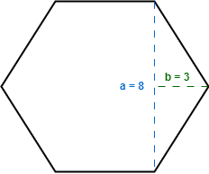
2. Design a Java program to calculate Sin and Cos values from a right-angled triangle.

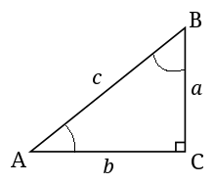

Assume the values of a and b are 4.5 and 9.5 respectively. Finally, print the Sin and Cos values of angle A and angle B (SinA, CosA, SinB, CosB). The formulas to calculate these values are given below.

**Hint:** You need the values for all 3 sides to calculate both sin and cos. You are given only a and b. How would you get the value of c? You’ll need the help of Math.sqrt().

